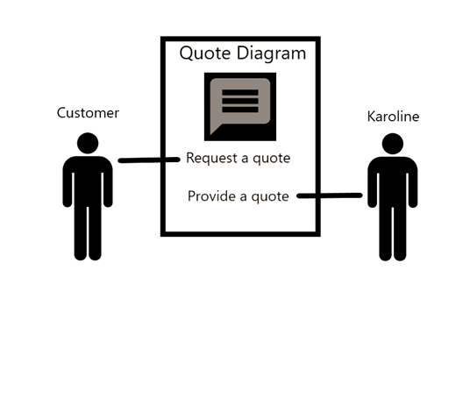

Creating a Quote Diagram

This diagram displays the process in which the customer asks Sweet Karoline’s Cakes for a quote on specialty or custom cakes and Sweet Karoline’s provides them with this information.